Chemosynthesis – a path to adapt to climate change and to discover a general formula for detect habitable (exo)planets in the galaxies
The project “Chemosynthesis – a path to adapt to climate change and to discover a general formula for detect habitable (exo)planets in the galaxies” is dedicated to chemosynthesis. Chemosynthesis is the process of producing energy by living organisms through chemicals and it tends to show us that sometimes life can occur in absence of sunlight and even of oxygen.
The project has many practical uses. It offers models for chemosynthetic life and data on which organisms can be apt to survive in outer space through models for chemosynthetic life (points 1. and 2.), but also it showcases how basic chemical principles can be used for detecting habitable (exo)planets across galaxies through characteristics that can be measured with current human technologies and tools (points 3 and 4.).
1. Models for chemosynthetic life
Most of the chemotrophs do not need sunlight to survive and no oxygen, they rely mostly on other chemicals – methanogens, sulphur oxidizers and reducers, nitrifiers, anammox bacteria, and thermoacidophiles, e.g.:
1. Anaerobic bacteria – e.g. nitrosomonas (uses only nitrogen to create energy for themselves), Beggiatoa (sulfur-oxidyzing), etc.
2. Some fungi species – can use carbon.
3. Some algae – can use carbon.
5. Some lichen – can use carbon, nitrogen, etc, given in Table 1.
The distinct characteristic of chemotrophs on Earth is that they are very small and simple, so unfortunately, we can’t expect that any complicated species can survive on other planets where conditions are harsh. But fortunately they may be able to survive in ambiances that are close to water found on Earth or in some kinds of atmosphere (although composition of gases there is different than ours).
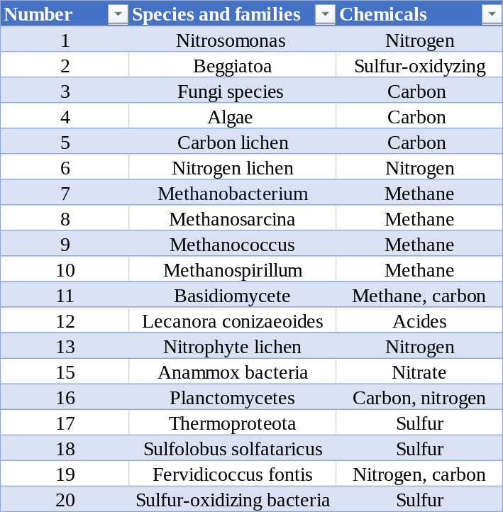
Table 1. Examples of anaerobic and chemotroph species and families of organisms present on Earth that may be able to survive in outer space
2. Repeating the evolution on closer planets by populating them with (micro)organisms that can survive there
Some countries have allegedly already tried years ago to “seed seeds” and “grow potatoes” on Mars, but as no more news on these projects, we can assume they have failed – the main reason for it seems to be the choice of species, not apt to survive there. But based on the general formula to detect habitable (exo)planets and on the fact that currently many microorganisms in Earth are able to live through chemosynthesis, we conclude that humanity can even repeat the evolution on other planets and space objects that are closer to Earth by populating them with species that can survive there.
For this purpose, we will need just a database with conditions that these species need to survive on the Earth and conditions (temperature, humidity, atmospheric pressure) on close planets. And the meeting point between these two sections in the database, this is the portfolio of organisms that can be sent to these planets and objects to “repeat the evolution”. Principles of chemosynthesis already observed on Earth lead us to the conclusion that chemosynthesis can occur on other planets, closer to ours or e.g. exoplanets. So, potentially current terrestrial chemotroph organisms that are able to survive by processing substances in dark ambiance (or less sunlight as quantity than what achieves the Earth) can survive and populate distant planets. The project brings a database of such organisms that can potentially survive in harsh conditions.
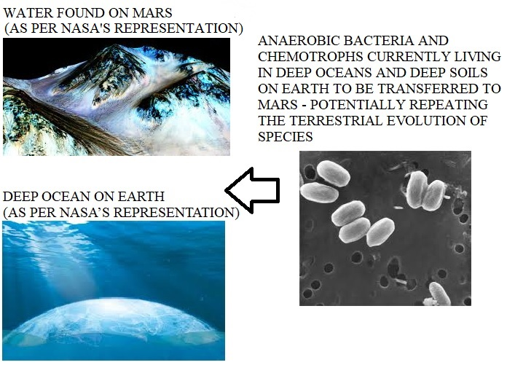
Picture 1. Potential applicability of chemosynthesis for populating planets in outer space
3. Basic chemical principles and factors for habitable conditions formation
Many scientists have tried to discover a path toward detecting if a planet is potentially habitable or not. Maybe the most notable example for it is the Drake equation. However, unfortunately our current technologies do not let us to detect in each observable galaxy numbers like mean number of planets that could support life per star with planets, fraction of life-supporting planets that develop life or fraction of planets with life where life develops intelligence.
NASA formulates several conditions that make a planet habitable such as magnetic field, atmosphere, habitable zone, stable rotation, climate, geological activity, liquid water, plate tectonics, presence of water. Unfortunately, all these factors are sometimes difficult to establish with our current technologies, as well.
In the aim to enrich the research for habitable planets, in this project, we are trying to develop an easy general formula to detect habitable exoplanets in the Universe, based on the primary principles of chemistry and chemosynthesis. It mainly uses as criteria for detecting potentially habitable exoplanets the basic chemicals principles that matter can be transformed when exposing on energy shocks and that properties like e.g. size, density, magnetic field can tell us what a planet or space object is made of and potentially, what it is able to support as living organisms. Adding to this that distance between the (exo)planet itself and the star in the relevant galaxy that provides it with energy, and we arrive to the primary factors determining the potential for habitable conditions. Another physical-chemical principle is that relative density and dimensions of an object can determine both its energy emittance capacity but also its energy storage capacity. It means that - even in most distant galaxies that we can observe - if we have a star that has close relative density to size ratio as our Sun, it can emit energy (in the form of photons) that can probably sustain life there. The next factor is that around this star orbits planets and/or objects that have a similar density to size ratio as the Earth, e.g., so they are able to store the energy they get at similar rate. All factors to take into account are discussed in the next point and on picture 2.
4. Model for detecting habitable (exo)planets
Main criteria:
- Density to size ratio of the star in the galaxy that emits energy (it determines the capacity and the quantity of energy that the star can emit as photons).
- Density to size ratio of the planet/object that receives energy (it determines the capacity of energy that the planet/object can store and the quantity of energy that it can receive).
- Average temperature to distance ratio of the star and the planet/object in the galaxy (it determines the quantity of energy emitted by the star that is able to achieve the planet/object, as photons seem to have different dispersion rates at different parts of the Universe).
- Magnetic field of the star to magnetic field the planet/object in the galaxy (it determines the gravitational forces within the galaxy and the ratio of rays that’ll achieve the planet versus the ones that are pushed aside).
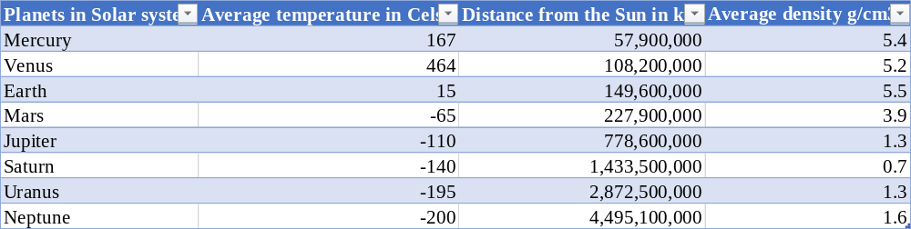
Table 2. Some data to be used to calculate ratios from the formula Solar system planets
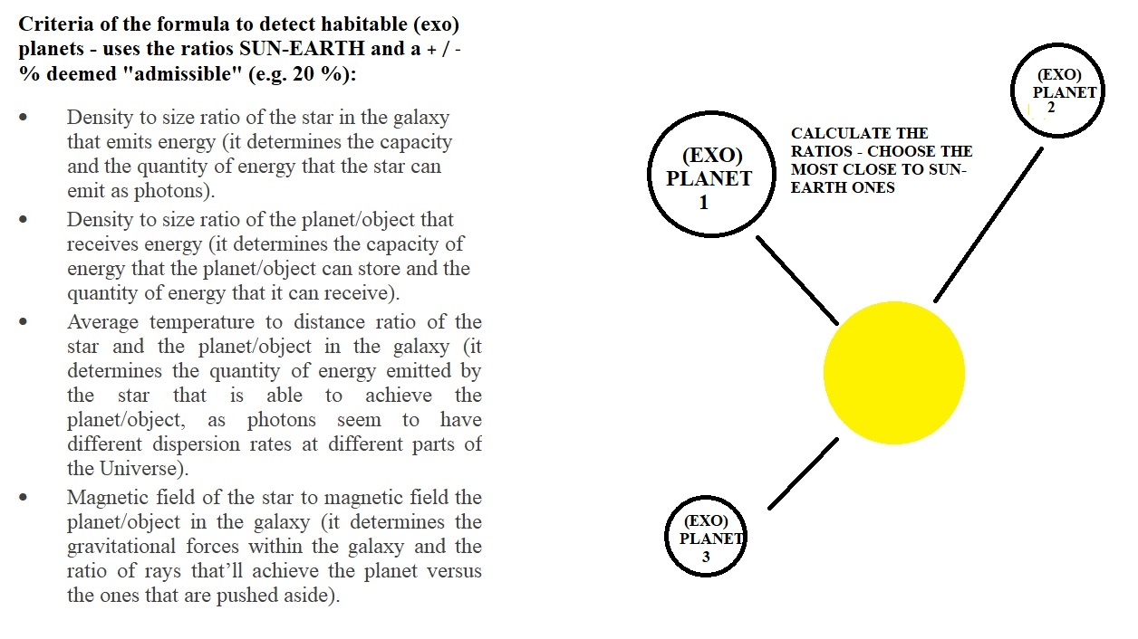
Picture 2. The criteria of the formula explained
The project does not require special tools, coding languages, hardware, or software. It can be implemented through existing simple data processing software or even on paper by making tables for chemotroph and anaerobic species that exist now of Earth and can be transported to populate other planets based on the dominant chemicals these species process through chemosynthesis. Same applies to the formula, as NASA already has an exoplanets archive database and most of the data on the ratios can be taken from this archive.
For potential use of the project for adapting to climate change, there will be needed a laboratory and specific chemicals to treat e.g. current seeds, so that they can be adapted to survive in harsh ambiance. It is a path to be developed further, including for both seeds and organisms to be adapted and to make them “evolving” faster to keep up with the pace of climate change.
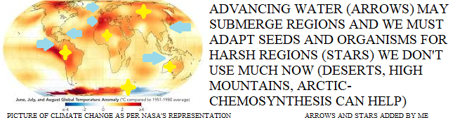
Picture 3. Potential applicability of chemosynthesis in seeds and organisms adaptation to climate change
References:
- https://cosparhq.cnes.fr/assets/uploads/2021/07/PPPolicy_2021_3-June.pdf
- https://earth.esa.int/eogateway/missions/smos/data
- https://exoplanetarchive.ipac.caltech.edu/
- https://nssdc.gsfc.nasa.gov/planetary/factsheet/
- https://oceanexplorer.noaa.gov/edu/materials/chemosynthesis-fact-sheet.pdf
- https://oceanworlds.space/
- https://science.nasa.gov/resource/solar-system-temperatures/
- https://www.asc-csa.gc.ca/eng/sciences/apex.asp
- https://www.nasa.gov/specials/ocean-worlds/
- https://www.nasa.gov/wp-content/uploads/2015/01/yoss_act1.pdf?emrc=8a0290
- https://www.ncei.noaa.gov/products/world-ocean-atlas

